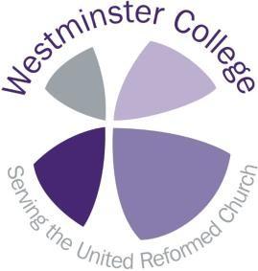We want to ensure that our archives are as comprehensive as possible

If you have any records which you think are important, please contact the archivist, Helen Weller, to discuss whether they might be of interest to the archives.
The following is intended as a guideline only.

What we collect
We would like to hear from you if you have:

• Records to do with Westminster College
• Records to do with Cheshunt College
• Records to do with the Presbyterian Church of England at national level
• Records to do with the Churches of Christ at national level
• Histories of individual churches
• Biographies of Presbyterian, Churches of Christ, or URC ministers
• Papers of Presbyterian, Churches of Christ, or URC ministers

Church Histories
We have a series of histories of individual churches and welcome additions to this sequence. Please check with us before sending anything, to prevent duplications. However, we regret that due to constraints of space, we cannot accept general research notes on the history of a church.

Records of a particular church
We do not hold the records generated by any individual churches or congregations. If you are responsible for the records of a particular church, and would like to transfer them safely, we would recommend that you speak to your local County Record Office to arrange this. If you’re not sure where your local CRO is, or who to speak to, let us know and we’ll try to help.

The records manager at URC Church House has written guides for people responsible for church or synod records, outlining which records to keep and which to dispose of. These guides are available online at http://www.urc.org.uk/resources/.

Records of the United Reformed Church from 1972
If you have records relating to the United Reformed Church since 1972, please contact

Shahera Begum, Records Manager at URC Church House, on 020 7691 9864
or recordsmanager@urc.org.uk

Congregationalist Records
If you have records of Congregational origin, please contact the Congregational
Library at Dr Williams’s Library.

Feature image: Detail of the College Register of Students from 1863-4. From
Westminster College Archive, WSR1/1

