Would you like to visit our Archives?

Visiting the Archives
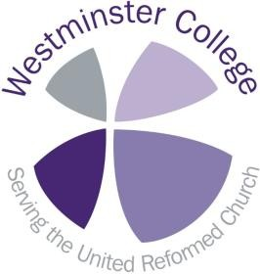You are welcome to visit the Archives at Westminster College. Our
records are irreplaceable and fragile, so like most archives, we ask that you do not eat or drink whilst looking at the records; and that you use only pencil, not pen, when taking notes. You are welcome to bring a laptop to use.

Opening times
The archives are open by appointment only on Monday to Thursday, from 9am until
2.30pm. Please contact the archivist in advance on hw374@cam.ac.uk to talk about what you would like to see and to make an appointment.

The archives will be closed from 1-1.30 for lunch. You are welcome to join us for lunch in the dining hall, though this must be booked in advance – please ask if you’d like to find out more about costs and booking. Otherwise, the College is only a five- or
ten-minute walk from the town centre, where there are plenty of places to eat.

Enquiry Service
We are happy to check whether we hold information on a person, church, or subject you are looking for –see below for details on contacting the archivist.

If we hold information relevant to your request, you are very welcome to make an
appointment to come in and look at our records, and we would be happy to help.

Copying and images
You are welcome to bring a camera and take photographs of the records for your own personal use, but we request that you do not use a flash. We’re sorry, but due to conservation and copyright reasons, we cannot usually photocopy records for you.

If you would like to publish your images, permission to reproduce any document must be sought prior to publication and due acknowledgment made.

Contacting the Archivist
If you would like to find out more about our archives, or arrange a visit, please contact the archivist, Helen Weller, on hw374@cam.ac.uk. Alternatively, you can write to the archivist at Westminster College, Madingley Road, Cambridge CB3 0AA; or leave a message on 01223 330620.

Please note, the archivist is part time and works in the mornings on Mondays - Thursdays.

Contacting the United Reformed Church History Society
For further information about the URC History Society, please see our URCHS
webpage here.

Contacting the College and how to find us
Westminster College is located in central Cambridge. For general enquiries about
Westminster College, including a map, please refer to the contacts page here.

Featured image: S.W. Carruthers of the Presbyterian Historical Society

