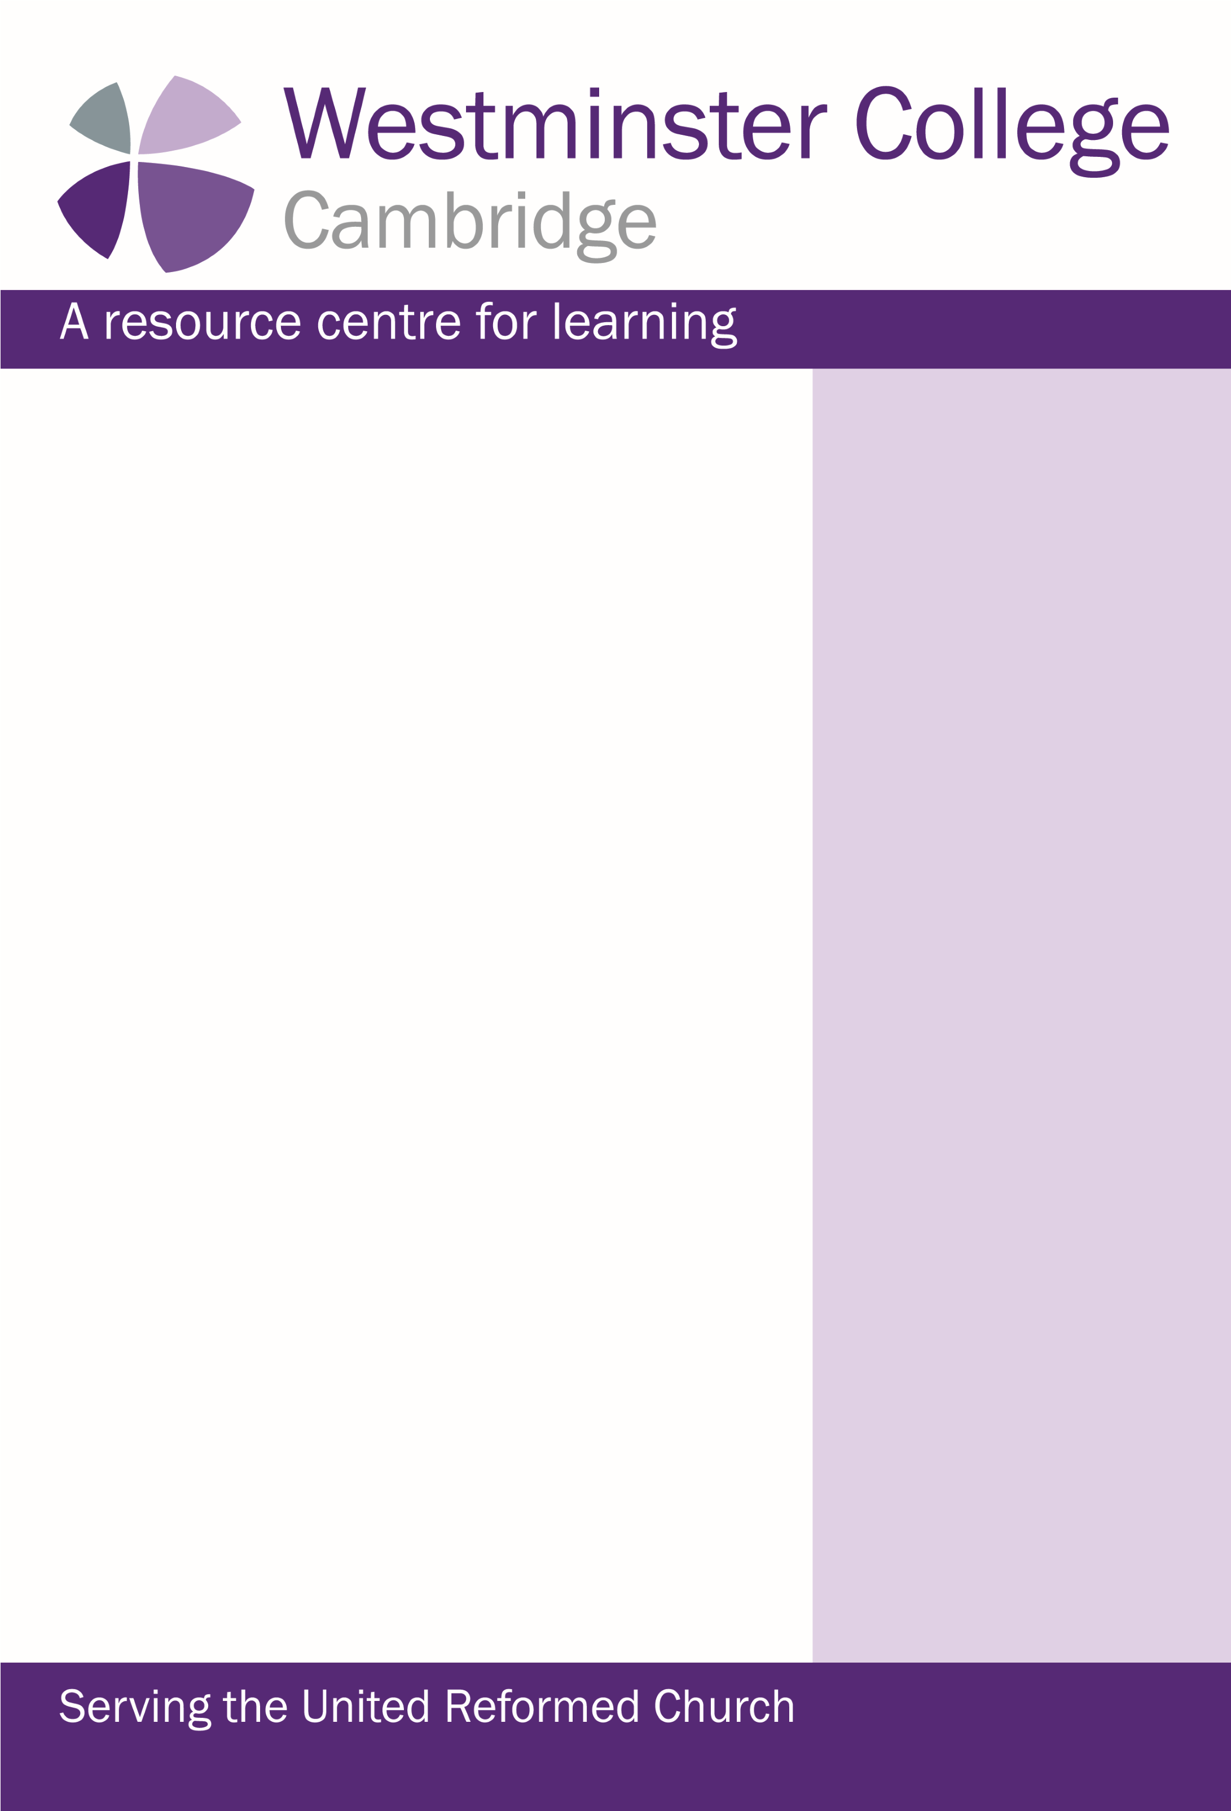

Since writing in February, our first Ministers Refresher Course has

taken place. The week was a sell out and it was a joy to welcome

ministers from across the denomination to Westminster for a time

away from busy ministries. Being able to offer a space for

relaxation, networking, creativity, prayer and worship alongside

quality teaching from David Cornick on new insights into John’s

Gospel, and great worship with our chaplain Linda Rayner was a

real blessing for our community. Next year we will have Dr Ed

Kessler with us and our theme will be “Living in a World of Faiths”.

June 1st saw the launch of our new Alumni and Friends

Association alongside of the unveiling of a blue plaque to honour

Agnes Smith Lewis and Margaret Dunlop Gibson, the sisters who

provided the site for Westminster College. The day was attended

by nearly 150 people and a reminder of just how many men and

women have loyally served and developed Westminster over the

years. Their legacy is a spur to those of us serving here now of

our need to continue to develop Westminster to meet the needs

of the URC in the 21st century.

If you wish to contact me with any thoughts, ideas or experience

you can offer to Westminster my contact details are below

Best wishes

Peter

Peter Ball

Director of Church Resource Development

Email: pb694@cam.ac.uk

Direct Line: 01223 33 06 26

Windows of opportunity

Issue 2

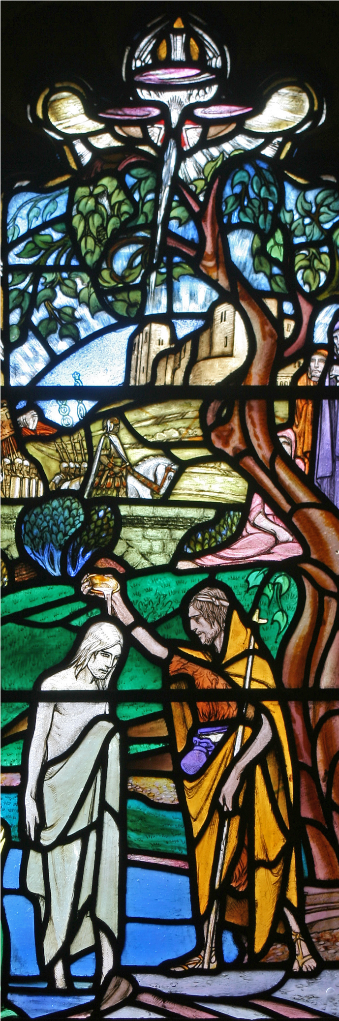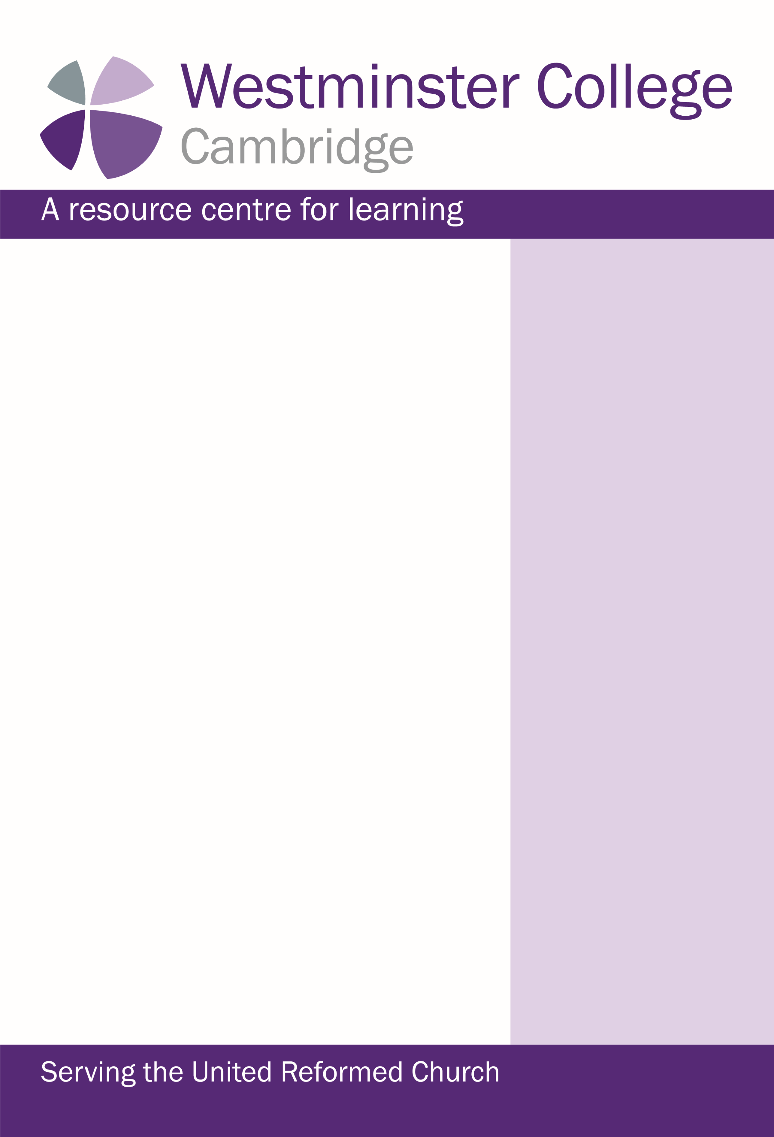

Coming Up 2019

Supporting Elders 2019

Friday 5th—Sunday 7th July

Lens, Pen and Paintbrush

Saturday 17th—Sunday 18th August

Supporting Lay Preachers and Worship Leaders—Sing a New Song—

The use of Scripture in Worship

Monday 12th – Wednesday 14th August

Friday 13th – Sunday 15th September

Blue Planet – Blue God

)

(

with The Faraday Institute & Wesley House

Wednesday 11th – Friday 13th September

What is it to be Human?

(

with The Faraday Institute

)

Saturday 2nd November –Understanding Dementia and Dementia

friendly worship

In the Company of…

The opportunity to enjoy space and time, to think, read, write and

talk. Dates to suit you.

Save the dates 2020

Ministers‘ Refresher Week

Monday 16th– Friday 20th March

Life Together—LEP’s Today & Tomorrow

(

With Wesley House

)

Saturday 6th June

*Further details on our website: www.westminster.cam.ac.uk*

FOR YOUR DIARY

BLUE PLANET BLUE GOD

Booking now

MINISTERS REFRESHER WEEK

March 16th-20th 2020

*Living in a World of Faiths*

Keynote speaker Dr Ed Kessler

LEP’s Today and Tomorrow

June 6th 2020

Keynote speaker Prof David Ford

You can come along and stay even

if you aren’t taking part in a course.

We have a number of different ac

-

commodation options and room

types suitable for a single night

through to a full term. URC

members are welcome to join us at

any time throughout the year, call

us on 01223 330630 (please tell

us you are part of the URC).

We now offer an early bird discount

on our URC events. Contact us for

details.