**westminster college PLACEMENTS**

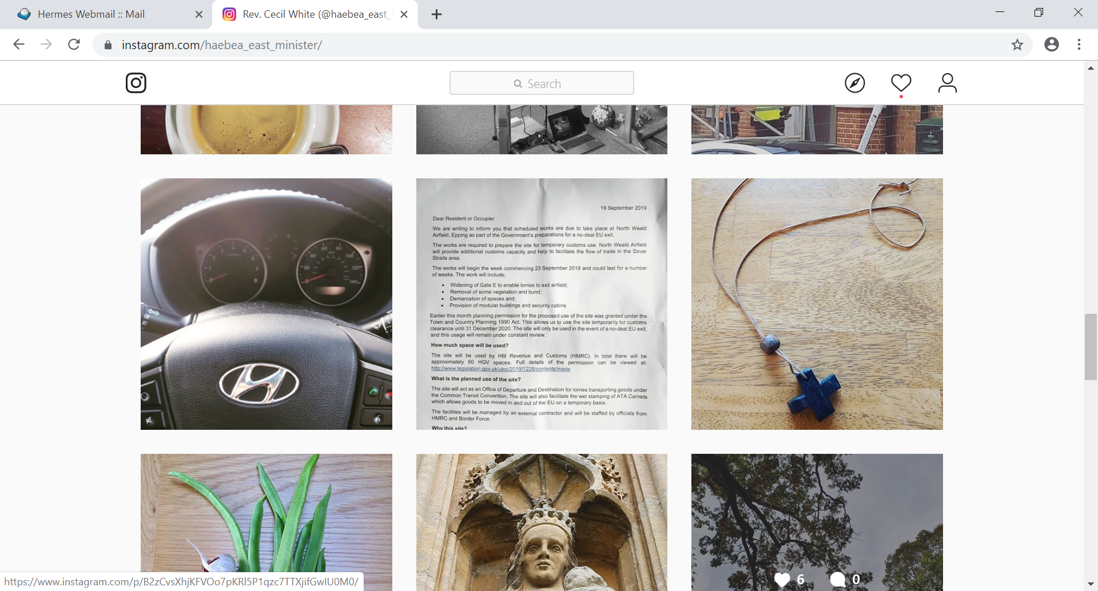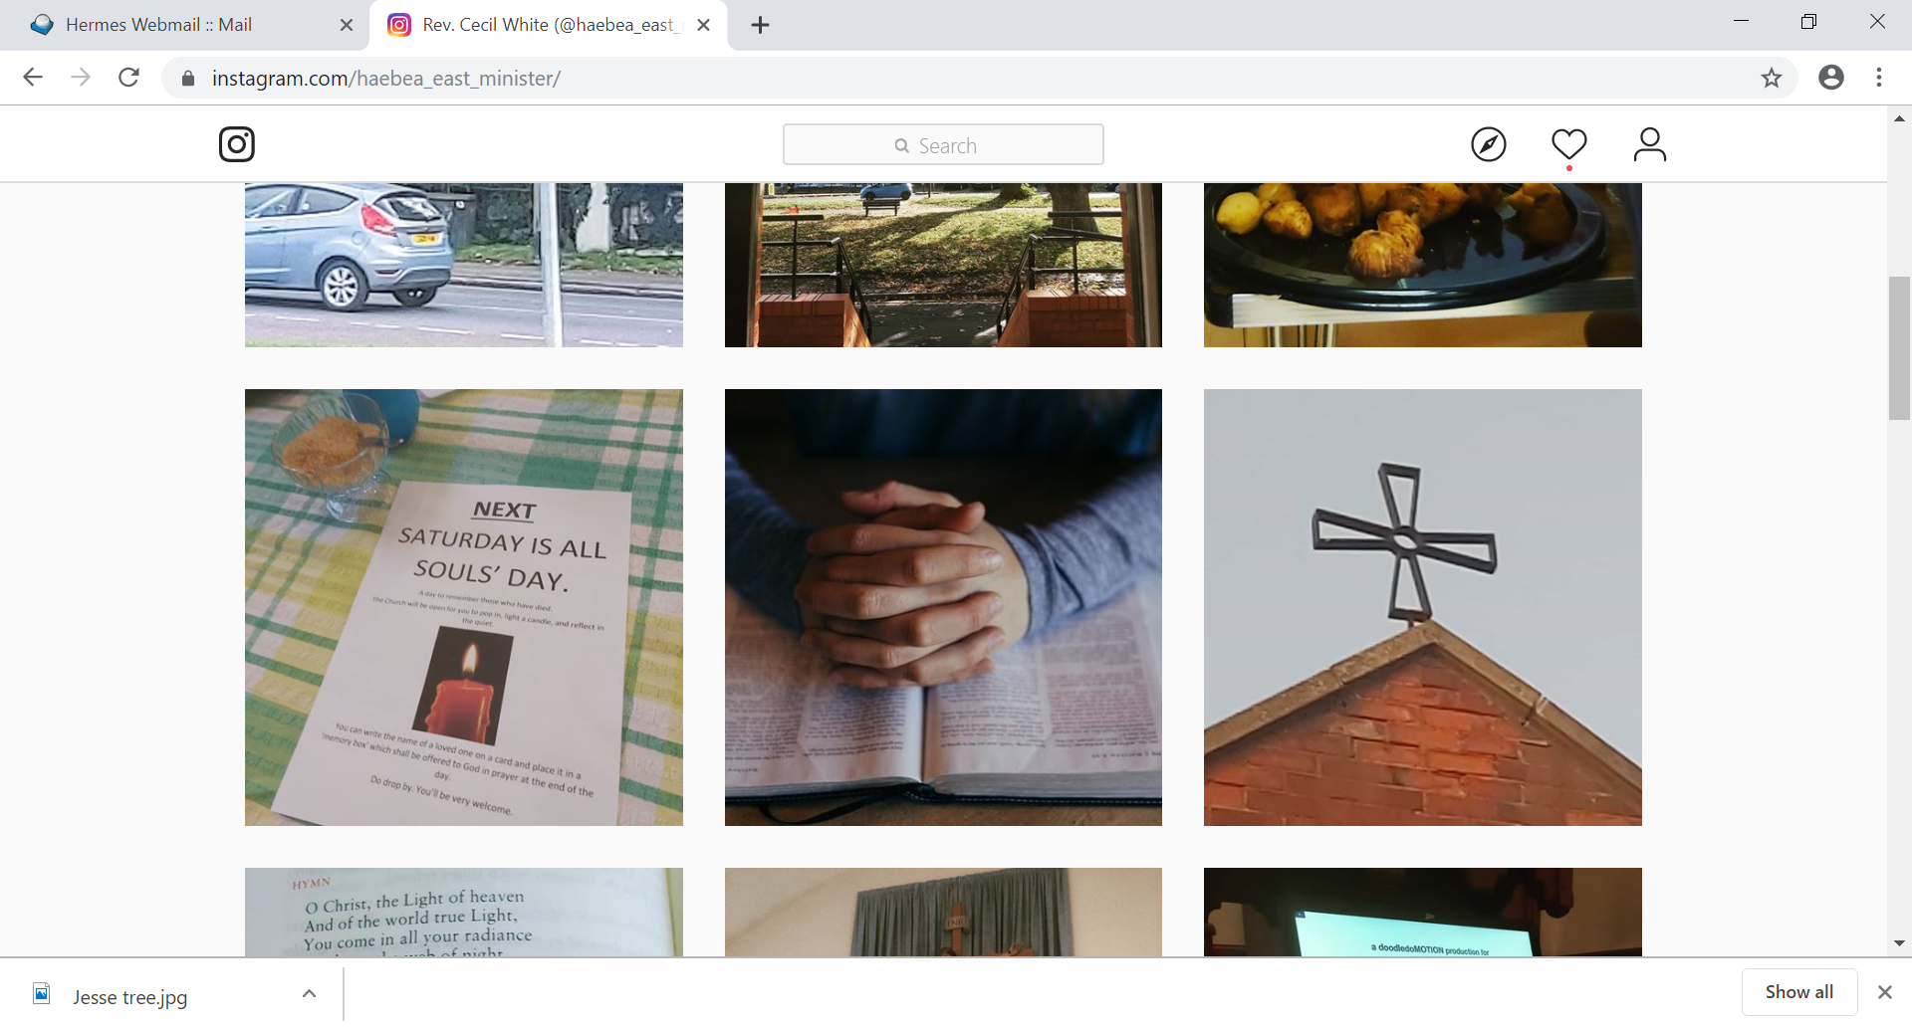

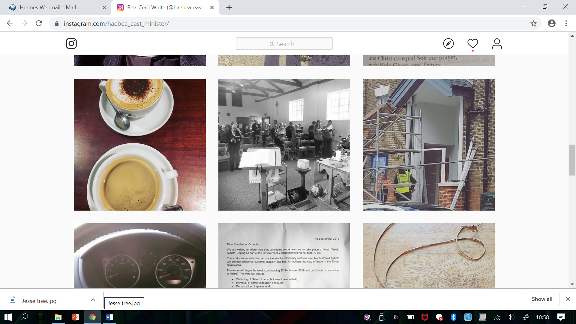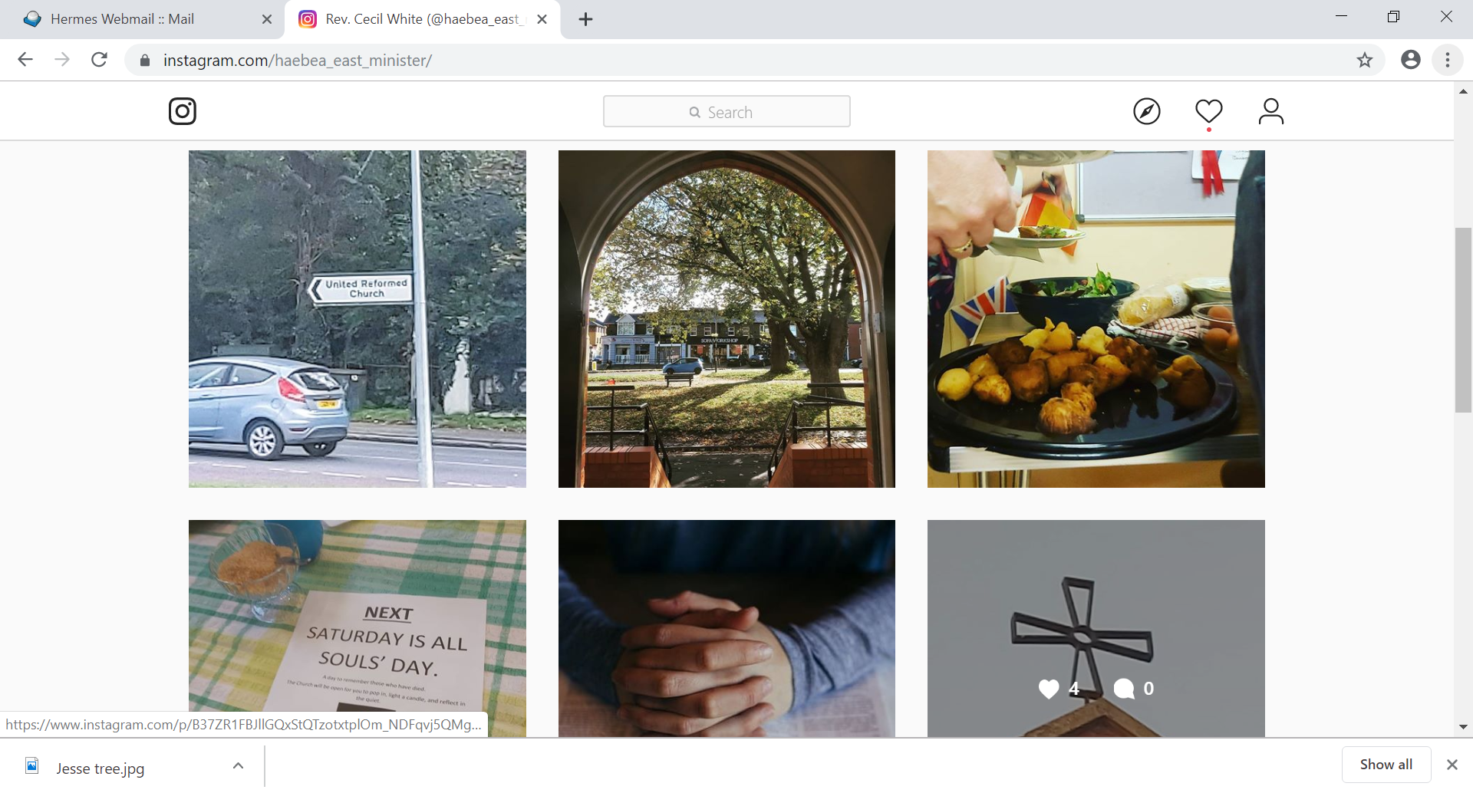

*Guidance for Placement Supervisors*

*2024-2025*

Table of Contents

Introduction **3**

Placement Basics: What? When? Where? Who? **3**

The Aims of the Placement (Student / Church/ Community…………………………………………………………………..**4**

Supervisors and Good Supervision **5**

Developing Student Competencies **7**

Practicalities .**8**

Placement Documents ............…………………………………………………………………………………………………………….**9**

1. Working Agreement Form: a. For churches; b. For social contexts ……………………………………..…**9**
2. Supervisor’s Report Form a. For churches; b. For social contexts ……………………………………..….**13**
3. Ethics Template…………………………………………………………………………………………………………………….**22**

# 

Introduction

Welcome to this guidance booklet which has been designed to assist you in learning more about student placements with Westminster College. These students are training to be church ministers within the United Reformed Church (URC). Through church-based and social context placements students are invited to explore the ways that faith and service are made visible in practice, in different situations. This will contribute to their vocational and formational development. The students will bring their skills and experience to your context with the intention of benefiting and serving your church or organisation.

Placement Basics

The aims of placements are:

* to root theological training and formation for ministry in the life, ministry and mission of a local church, pastorate or community context where a Christian presence is to be found.
* to bring assumptions, both theological and practical, into active contact with ministry to provoke further questions, stimulate reflective practice and theological reflection, thus deepening formational learning.
* to offer hands-on experience in a range of ministerial practices.
* to maintain an active relationship with the wider church and community beyond Westminster College.
* to facilitate learning at several levels including personal and spiritual development; personal and professional relationships; ministerial skills; growth in knowledge and understanding of the ministry and mission of the church.

**What?**   
  
Every student training as a Minister of Word and Sacraments in the United Reformed Church is required to undertake a variety of placement experience. All students will have the opportunity to undertake shorter placements in church-based contexts or in other social contexts, such as community organisations or institutions where ministry takes place e.g. hospital, hospice, police, workplace, shopping centre, waterways.

**When/How?**

**There are different types of placements including:**

* Weekly termly placements which may take place alongside academic study. For full-time students placements within a church context would include a Sunday and afternoon/evening mid week.
* Block placements happen over concentrated short periods, often in vacation time, or throughout the whole academic year for one session per week, fitting around lectures and private study. Every student is required to complete a one-week fulltime Christmas and one week Easter placement each year (or two weeks part-time for each)
* Summer placements include 2 x 4-week or 1 x 8-week summer placement / social context placement / overseas. To include regular attendance; leading worship and preaching; participation in church meetings; pastoral meetings; occasional offices (weddings, baptisms, funerals, etc.)

**Where?**

Arrangements may be made for students so that they can either:

* commute daily to a context near where they live (normally up to an hour from home)
* with a local family for short placements located away from home or in a B&B

**Who?**

Four parties are involved in this exercise: the student, the College, the church or social context, and the agreed supervisor (normally the minister or lead chaplain/organiser)

1. *The Student*
2. *Westminster College*facilitated by the Director of Pastoral Studies, Dan Pratt djp208@westminster.cam.ac.uk
3. *The Church or Social Context Organisation*
4. *The agreed Supervisor* (normally the minister or lead chaplain/organiser)

The Aims of the Placement

1. **Student**

The aim of the placement is to enable the student to observe and reflect on what is happening in the local church and community. This will involve experiencing the realities of ministry, participating in the life and routine of the local church or social context, and reflecting theologically with the supervisor on this experience at the beginning and end of the placement.   
  
A church-based placement may include engaging in issues such as:

* approaches to mission and discipleship
* preaching and leading worship during the Christian year
* pastoral care
* engagement with children and young adults, e.g. uniformed organisations or Messy Church
* community projects e.g. church café, foodbank, refugee project, lunch club
* staff meetings and committee meetings

A social-context placement may include engaging in issues such as:

* social welfare
* pastoral care e.g. hospital or hospice chaplaincy
* team-working e.g. Street Pastors
* befriending
* practical assistance utilising the resources of the organisation e.g. distributing food at a foodbank.

1. **Local Church(es) and Community**

Churches are asked to encourage students to relate to the life of the whole people of God, and not just to the work of the minister. We therefore encourage members of the church community to take responsibility for providing appropriate support, encouragement and constructive criticism.

Social context community placements are asked to encourage students to engage in community service and activities that they may not have previously experienced. They are encouraged to reflect on the value of charities and organisations that promote social justice, community inclusion and the promotion of well-being.

Whether it is a church-based placement or social context, it will be necessary for the supervisor to fulfil the requirements of Ethical practice and General Data Protection Regulation (GDPR) by signposting the student’s presence on placement in advance of their arrival (see *practicalities and forms below*).

Supervisors and Good Supervision

1. **The Supervisor**

The minister or organisation leader is normally the student's supervisor on placement. This leader may delegate the task to an experienced ordained colleague or appropriate departmental leader. It would be helpful to inform college where this occurs.

For short placements it is expected that students will meet with supervisors for supervision *at least* at the beginning and end of the placement. For longer placements, meeting with the student at least every two weeks would be beneficial.

The first meeting will need to be a practical planning session and requires the completion of the Student Working Agreement (see the section on *Supervision* and *forms* below*)*. The student and supervisor should seek to establish a *Working Agreement* as the basis for the placement. Ideally this should be done as early as possible.

The supervisor is asked to allow the student to play as full a part as possible in the work of the church or organisation. The student will need to explore ministry and service in that context through the lens of the URC Minister’s Marks of Ministry (page 7).

The supervisor and supervisions can be enormously formative in students’ training and ministerial formation. Supervisors are there to direct and guide the student in their contextual learning, as well as support them in their ministry experience.

A supervisor’s report is to be submit upon completion of the placement (attached below). If the placement is 8 weeks or longer, it is requested that the supervisor submit an interim report (below). The feedback could be discussed with the student within a supervisory session to enable their input into the process.

**Setting learning objectives**

Setting learning objectives for a placement helps to give direction for the student’s experience and criteria for his/her/their growth and learning.

It is most helpful to settle on just a few learning objectives that seem particularly pertinent for the individual student and the context of the church or social context.

The learning objectives will articulate what the student hopes to learn and how the activities and experiences of the placement will enable them to do so.

**What makes good supervision?**

Supervision is more than diary planning and pastoral care, although these are vital aspects of enabling a student to succeed in completing a fruitful and meaningful placement. Supervision is also the building of a rapport that enables insightful questions to be asked. The following questions may be helpful ways to reveal hidden depths for exploration.

|  |  |
| --- | --- |
| **Facts** | What are the facts of the situation or experience and what is opinion or hearsay? |
| **Feelings** | What feelings have been aroused? |
| **Fantasies** | Are there fantasies, stereotypes, fears or prejudices that need to be brought to light? |
| **Focus** | What is at the (theological) heart of the situation or experience? |
| **Faith** | Is faith exercised – and what does it mean – in this experience? |
| **Future** | What has changed because of reflecting together? What will we do, or how will we think, differently? |

**The supervision session: involving self and others**

Supervision is at its most effective when it engages the supervisor as much and as vulnerably as the students. When the dynamic moves from teacher and student to co-learners in God’s kingdom, deep and transformational learning begins to take place. This can be a costly but energising and stimulating experience for the supervisor as well as for the student!

Although the relationship between student and supervisor is vital, it is equally important to model and give opportunities for others in the church or chapel to be a part of such reflections. This is one way of embodying collaborative ministry and the releasing of the whole people of God into service and leadership.

|  |
| --- |
| **Developing Student Competencies: A Minister of Word and Sacrament is …** |
| **1. A FAITHFUL DISCIPLE OF JESUS CHRIST:** caught up in the joy and wonder of God’s will and work; seeking always to live a holy life in public and in private; sustained by their own rhythm of prayer, Bible reading and worship so that they might model and encourage such life-long patterns in others with integrity; open to learning discipleship from others. |
| **2. A PERSON OF INTEGRITY AND RESILIENCE**: self-aware and committed to their own lifelong learning (especially through the URC’s provision for ministers); aware of their own limitations and thus willing to seek support; ready to deal with situations of conflict; balancing ministry’s joys and pains with the fostering of right relationships with family and friends. |
| **3. A THEOLOGIAN:** delighting in Scripture, rooted in the Reformed tradition, able to communicate their own faith and its implications within and beyond congregations; encouraging others to discover how these rich resources inspire and sustain faithfulness. |
| **4. A WORSHIP LEADER AND PREACHER:** able to craft and lead worship that show an appreciation for the Sacraments and the resources of many traditions and styles yet unafraid to create and advocate new forms as appropriate; passionate and effective in breaking open God’s Word in preaching; ready and able to foster skills, techniques and experience in others so that they might lead worship and preach well. |
| **5. A PASTOR:** sharing with others, especially Elders, in sustaining care; making time to walk in love alongside people; rejoicing and grieving with others through listening deeply and offering prayerful support; wise in knowing their limits and boundaries when more specialised help is needed; reliably dealing with issues of safeguarding and confidentiality. |
| **6. A LEADER AND COLLABORATOR:** identifying, developing ,and enabling others, particularly Elders; capable of working in ,and leading, teams through collaborative and shared leadership; aware of their own leadership style and open to learning with and from others, when necessary acknowledging their own mistakes and seeking restoration; committed and equipped to building up others in faith and witness so that the gifts and callings of all might flourish; demonstrating love for God’s people. |
| **7. A MISSIONARY AND EVANGELIST:** passionate about and active in sharing the love of God for the world; alive to the significance of contexts and culture in shaping mission and creative in discovering missional opportunities; empowering and equipping God’s people in mission to share the Gospel and live God’s Kingdom of justice and people to the full. |
| **8. A PUBLIC FIGURE:** reliable and effective in representing the Church in ecumenical, community and wider settings; committed to and equipped in speaking truth to power and challenging injustice and marginalisation wherever they may be found. |
| **9. A COMMUNICATOR:** who uses written, spoken and other modes with clarity and grace to share faith and build up relationships and communities; helping others to find their voice. |
| **10.** **A COMMITTED PARTICIPANT IN THE COUNCILS OF THE CHURCH:** responsive to God’s call as gift and blessing to be lived out within the discipline and accountability of the denomination which trains, ordains and inducts them and the pastorates and ministries within which they serve. |
| **11. A REFORMER**: wise in the dynamics and challenges of change; bold yet humble in helping individuals and congregations to discern and respond to the leading of the Holy Spirit as new chapters open in the life of the Church and others close. |

Practicalities

**Finances**

It should not cost your church or organization to host the student. Certain expenses may be claimed by the students from Westminster College. They can use *Westminster College Student Expenses Claim Form* available from the tutorial office. **Receipts will be required wherever possible.**

Travel to placements in the UK: Students may claim the cost of travel to and from a church or social context placements.

Placement Documents (included below)

**Working Agreement** (included below for both churches and social context placements)

Placement supervisors are requested to complete *a Working Agreement* form as soon as possible at the beginning of the placement. This is normally done during the initial meeting of supervisor and student. This form helps students and supervisors agree on expectations of work and areas of ministry / experience that they will be involved in. This needs to be returned by the student to **Syd Harper** ([admin@westminster.cam.ac.uk](mailto:admin@westminster.cam.ac.uk)) as soon as possible after the beginning of the placement.

**Placement Checklist**

All placement supervisors are requested to complete a *Placement Checklist* at the beginning of the placement. This ensures that practices are compliant with safeguarding and safe practice guidelines, and the Cambridge and Durham Universities’ Ethics and Good Practice guidance. This needs to be returned to **Syd Harper** as soon as possible after the beginning of the placement.

**Supervisor’s Report** (included below for both churches and social context placements)

As the placement is a formal element in the student’s training, a *Supervisor's Report* will be required. This must be returned to **Syd Harper** as soon as possible after the end of the placement. It is necessary to have a signed copy of the report for the files, but it would be helpful to have an electronic copy as well. If the placement is 8 weeks or longer, it is requested that the supervisor submit an interim report (attached below).

**Ethics Template**

This template is used by the placement provider and is intended to help the student comply to the university research ethics regulations as they undertake placements and prepare written theological reflections.

For further information, please contact Westminster’s Director of Pastoral Studies (DOPS), Dan Pratt ([djp208@westminster.cam.ac.uk)](mailto:djp208@westminster.cam.ac.uk))

**Church Context Placement**

**WORKING AGREEMENT**

*The student and the on-site supervisor are asked to agree the basis for the placement using this form. This form should be signed and returned to Westminster College, Madingley Road, Cambridge CB3 0AA (for the attention of the Tutorial Office or emailed to admin@westminster.cam.ac.uk) as soon as possible after the start of the placement. The details of this agreement may need to be adjusted according to the nature of this placement and some evaluation of how much of this agreement is being delivered should be part of regular supervision.*

**Student’s Name:** …………………………………………………………………………………………..……

**On-site Supervisor’s Name:** …………………………………………………………………………………………………

**Placement Location:** ………………………………………………………………………………………………………….

**Placement Start Date:** ____ / ____ / ________ **End Date:** ____ / ____ / ________

**Normal Working Periods** (Please indicate hours, days):…………………………………………………………

**WORKING AGREEMENT: SETTING YOUR GOALS**

* Consider – where have you got to and what do you now want to learn and experience? Discuss this with your supervisor, college tutor and pertinent others.
* Begin to identify learning goals under the headings used in our annual report (an example is given on the next page).
* Now list at least one, but no more than three, goals under these headings that relate to your learning goals, setting specific tasks to accomplish these goals.
* Now indicate which activities in the context will enable you to engage with that goal.

**Involvement and Tasks** Please identify up to three headings and suggest two to three ways you might develop these in this placement.

A URC Minister of Word and Sacrament is someone who is …

1 = A FAITHFUL DISCIPLE OF JESUS CHRIST

2 = A PERSON OF INTEGRITY AND RESILIENCE

3 = A CONTEXTUAL THEOLOGIAN

4 = A WORSHIP LEADER AND PREACHER

5 = A PASTOR

6 = A LEADER AND COLLABORATOR

7 = A MISSIONARY AND EVANGELIST

8 = A PUBLIC FIGURE

9 = A COMMUNICATOR

10= A COMMITTED PARTICIPANT IN THE COUNCILS OF THE CHURCH

11= A REFORMER

The annual report concentrates on the gifts and graces, skills and competencies that have been identified as required to fulfil the tasks listed above. These are …

1 = A FAITHFUL DISCIPLE OF JESUS CHRIST

2 = WILLINGNESS TO TAKE A FULL PART IN THE LIFE OF THE COLLEGE

3 = OPENNESS TO LEARN THROUGH CLASSROOM, PLACEMENTS AND COMMUNITY

**4 = COMMUNICATE WELL IN SPOKEN AND WRITTEN WORD**

5 = EXHIBIT PASTORAL GIFTS AND SENSIBILITIES

6 = SHOW SELF-AWARENESS

7 = DISPLAY HUMILITY AND COURAGE

8 = PERSEVERE AND DEMONSTRATE RESILIENCE

When you choose the gifts and graces, skills and competencies you hope to show in engaging in this placement, please keep in mind how they relate to the 11 marks of ministry listed above. This is listed in the document (previously distributed) called ‘Gifts and Graces, Skills and Competencies’.

**EXAMPLE: heading 4 – COMMUNICATE WELL IN SPOKEN AND WRITTEN WORD**

Your goal might be ‘I want to improve my communication with the congregation’.

* Task 1= ‘by the end of the placement I will have led worship and received feedback on form, structure and content; on how I interpreted scripture; on skills in leading the congregation’.
* Task 2= ‘I will write a piece for the church’s website or newsletter and invite feedback on clarity of thought and expression’.
* Task 3= ‘I will discuss good practice with my supervisor and write a reflective document about future communication in a pastorate’.

**1 = A FAITHFUL DISCIPLE OF JESUS CHRIST**

**2 = OPENNESS TO LEARN THROUGH PLACEMENTS AND COMMUNITY**

**3 = COMMUNICATE WELL IN SPOKEN AND WRITTEN WORD**

**4 = DEVLOP PASTORAL GIFTS AND SENSIBILITIES**

**5 = DEVELOP APPROPRIATE RELATIONSHIPS WITH A VARIETY OF AGE RANGES**

**6 = DEMONSTRATE APPROPRIATE LEADERSHIP SKILLS**

**Ethical and Safeguarding Practice:**

*It is important to ensure that you and the church are willing to abide with good ethical and safeguarding practice. Please tick in the box below*

1. The church has received and made public a notification that the student

will be using information gained through experience on placement to

reflect on ministerial practice.

1. The student has demonstrated they have enhanced DBS clearance.
2. That the student is appraised of the church’s safeguarding policy and

relevant officer.

**Supervision Arrangements** (Please indicate frequency and duration of supervision)

**Student’s Signature :…………………………  
Supervisor/s Signature/s……………….………………..………….  
Date this agreement signed:** ____ / ____ / ________

**Social Context Placement**

**WORKING AGREEMENT**

*The student and the on-site supervisor are asked to agree the basis for the placement using this form. This form should be signed and returned to Westminster College, Madingley Road, Cambridge CB3 0AA (for the attention of the Tutorial Office or emailed to admin@westminster.cam.ac.uk) as soon as possible after the start of the placement. The details of this agreement may need to be adjusted according to the nature of this placement and some evaluation of how much of this agreement is being delivered should be part of regular supervision.*

**Student’s Name:** …………………………………………………………………………………………..……

**On-site Supervisor’s Name:** …………………………………………………………………………………………………

**Placement Location:** ………………………………………………………………………………………………..

**Placement Start Date:** ____ / ____ / ________ **End Date:** ____ / ____ / ________

**Normal Working Periods** (Please indicate hours, days):………………………………………………………….

**WORKING AGREEMENT: SETTING GOALS**

* Student to consider – where have you got to and what do you now want to learn and experience? Discuss this with your supervisor, college tutor and pertinent others.
* List at least one, but no more than three, setting specific tasks to accomplish these goals.
* Now indicate which activities in the context will enable you to engage with that goal.

**Ethical and Safeguarding Practice:**

*It is important to ensure that you and the organisation are willing to abide with good ethical and safeguarding practice. Please tick in the box below*

1. The organisation has received and made public a notification that the student

will be using information gained through experience on placement to

reflect on ministerial practice.

1. The student has demonstrated they have enhanced DBS clearance.
2. That the student is appraised of the organisations’s safeguarding policy and

relevant officer.

**3. Supervision Arrangements** (Please indicate frequency and duration of supervision)

**Student’s Signature:………………………………………………….**

**Supervisor/s Signature/s……………….………………..………….**

**Date this agreement signed: ____ / ____ / ________**

**Church Context Placement**

**SUPERVISOR’S REPORT**

*The supervisor is asked to complete this report as soon as possible at the conclusion of the student’s placement. The supervisor may find it helpful to consult the working agreement to inform the range of learning envisaged. The report should then be shown to the student, before it is signed by both the supervisor and student and returned to Westminster College, Madingley Road, Cambridge, CB3 0AA (marked for the attention of the* ***Director of Pastoral Studies, or emailed to*** [***Syd***](mailto:smw80@cam.ac.uk) ***Harper sh658@westminster.cam.ac.uk****)*. *NB: Please type your report if possible. Thank you.*

**Student’s Name: …………………………………………………………………………………………………………..**

**Supervisor’s Name: ……………………………………………………………………………………………………….**

**Name of the church(es): ………………………………………………………………………………………………...**

**Dates of Placement:………………………………………………………………………………………………………..**

**Survey of work undertaken** (please list briefly the main activities undertaken and the kind of experience gained, stating frequency or amount of time involved):

1. **Discipleship, Vocation and Spirituality**

* What signs were there of the quality of the student’s faith and spirituality?
* Does the student have a realistic understanding of the nature of ordained ministry and of the church?
* What spiritual gifts and abilities did you observe?

1. **Character and Relationships**

* Did the student show a capacity to respond appropriately to people within a variety of relationships, and in what ways?

1. With clergy and church staff
2. With members of the church
3. With people or agencies outside the church (if relevant)

* Was the student open to learning and to engaging with constructive comments on tasks performed?
* How did the student respond to conflict and/or strong personalities?
* What strengths and qualities of character did you observe?
* What weaknesses, or areas in need of attention, did you observe?
* What evidence of self-awareness was there of all the above?
* To what extent was the student able to reflect theologically and to relate theory to practice?

1. **Worship Leading and Preaching, Leadership Qualities**

* In what ways did the student demonstrate an understanding of preaching and leading

public worship, and an ability to engage in them appropriately?

* Was the student clear and engaging in their communication with others?
* What evidence was there of the student’s leadership style, e.g. was the student able to work collaboratively and in a team?
* In what ways did the student demonstrate other skills, e.g. teaching, administration, taking initiative?

1. **Pastoral Care, Mission and Evangelism**

* How far and in what ways did the student demonstrate a range of pastoral skills appropriate to the church context?
* Did the student gain and show a knowledge and understanding of the geographical, social, cultural, political etc. characteristics of the context?
* How effectively did the student grasp and participate in the mission and evangelism of the church?

1. **Further Training Needs**

* What needs for further training and development have you identified the student as having in order for them to grow in their understanding and practice of ordained ministry?
* Please include in this section any issues that, in your opinion, the student needs to address to be ready for ordination. *(Don’t worry if there aren’t any!)*

1. **Any Further Comments:** (Please don’t feel you have to make any if you have said all that you want to say in the previous sections of the report).

**Did you discuss the content of this report with the student before, during or after writing it?**

**Supervisor’s Signature: ………………………………………………………………………………………………………**

**Supervisor’s Signature: ……………………………………………………………………………………………………….**

**Date: …………………………………………………………………………………………………………………………………...**

*Thank you for your supervision and for taking the time to complete this form.*

*Material from the report may be used in the End of Year Reporting process. For students taking the B.Th. or Common Awards qualifications this report may be made available to the examiners*

**Church Context Placement**

**SUPERVISOR’S INTERIM REPORT  
For use in placements of 8 weeks or longer**

*The supervisor is asked to complete this interim report as soon as possible please. The supervisor may find it helpful to consult the working agreement to inform the range of learning envisaged. The report should then be shown to the student, before it is signed by both the supervisor and student and returned to Westminster College, Madingley Road, Cambridge, CB3 0AA (marked for the attention of the* ***Director of Pastoral Studies, or emailed to*** [***Syd***](mailto:smw80@cam.ac.uk) ***Harper sh658@westminster.cam.ac.uk****)*. *NB: Please type your report if possible. Thank you.*

**Student’s Name: …………………………………………………………………………………………………………..**

**Supervisor’s Name: ……………………………………………………………………………………………………….**

**Name of the church(es): ………………………………………………………………………………………………...**

**Dates of Placement:………………………………………………………………………………………………………..**

**Survey of work undertaken** (please list briefly the main activities undertaken and the kind of experience gained, stating frequency or amount of time involved):

1. **Discipleship, Vocation and Spirituality**

*So far, on this placement –*

* What signs were there of the quality of the student’s faith and spirituality?
* Does the student have a realistic understanding of the nature of ordained ministry and of the church?
* What spiritual gifts and abilities did you observe?

1. **Character and Relationships**

*So far, on this placement –*

* Did the student show a capacity to respond appropriately to people within a variety of relationships, and in what ways?

1. With clergy and church staff
2. With members of the church
3. With people or agencies outside the church (if relevant)

* Was the student open to learning and to engaging with constructive comments on tasks performed?
* How did the student respond to conflict and/or strong personalities?
* What strengths and qualities of character did you observe?
* What weaknesses, or areas in need of attention, did you observe?
* What evidence of self-awareness was there of all the above?
* To what extent was the student able to reflect theologically and to relate theory to practice?

1. **Worship Leading and Preaching, Leadership Qualities**

*So far, on this placement -*

* In what ways did the student demonstrate an understanding of preaching and leading

public worship, and an ability to engage in them appropriately?

* Was the student clear and engaging in their communication with others?
* What evidence was there of the student’s leadership style, e.g. was the student able to work collaboratively and in a team?
* In what ways did the student demonstrate other skills, e.g. teaching, administration, taking initiative?

1. **Pastoral Care, Mission and Evangelism**

*So far, on this placement –*

* How far and in what ways did the student demonstrate a range of pastoral skills appropriate to the church context?
* Did the student gain and show a knowledge and understanding of the geographical, social, cultural, political etc. characteristics of the context?
* How effectively did the student grasp and participate in the mission and evangelism of the church?

1. **Further Training Needs**

*Referring to the objectives identified in the placement working agreement –*

* What needs for further training and development have you identified the student as having in order for them to grow in their understanding and practice of ordained ministry?
* Please include in this section any issues that, in your opinion, the student needs to address to be ready for ordination. *(Don’t worry if there aren’t any!)*

1. **Any Further Comments:** (Please don’t feel you have to make any if you have said all that you want to say in the previous sections of the report).

**Did you discuss the content of this report with the student before, during or after writing it?**

**Supervisor’s Signature: ………………………………………………………………………………………………………**

**Supervisor’s Signature: ……………………………………………………………………………………………………….**

**Date: …………………………………………………………………………………………………………………………………...**

*Thank you for your supervision and for taking the time to complete this form. Material from the report may be used in the End of Year Reporting process. (For students taking the B.Th. or Common Awards qualifications this report may be made available to the examiners.)*

**Social Context Placement (SCP)**

**SUPERVISOR'S REPORT**

*The supervisor is asked to complete this report as soon as possible at the conclusion of the student’s placement. The supervisor may find it helpful to consult the working agreement to inform the range of learning envisaged. The report should then be shown to the student, before it is signed by both the supervisor and student and returned to Westminster College, Madingley Road, Cambridge, CB3 0AA (marked for the attention of the* ***Director of Pastoral Studies or emailed to Syd Harper sh658@westminster.cam.ac.uk)***. *NB: Please type your report if possible. Thank you.*

|  |  |
| --- | --- |
| **Student’s name:** |  |
| **Supervisor’s name:** |  |
| **Federation College:** |  |
| **Dates of placement:** |  |
| **Location of placement:** |  |

*The purpose of this report is to ascertain the capacity of the student to engage pastorally with the chosen context.*

*From a ‘skills’ perspective we are interested in the student’s capacity to*

* *be punctual, personable, appropriately presented.*
* *listen and respond appropriately to those they meet.*
* *work collaboratively and responsibly with colleagues.*
* *be able to identify and learn from mistakes and to demonstrate self-awareness.*

*At a reflective, theological level we are interested in the student’s capacity to:*

* *use the resources of the faith tradition appropriately with clients/the public (e.g. to be a person of faith in a public setting in an appropriate way)*
* *observe and interpret the values of the institution/context (in theory and practice)*
* *reflect on where power lies.*

*In the light of these expectations, we would value your feedback on the following:*

1. **Survey of work undertaken.**
2. **Assessment of student engagement**
3. **Practical and Professional Skills**.
4. **Knowledge and Understanding**
5. **Personal and Professional Relationships**
6. **Personal Learning and Development**
7. **Communication**

|  |
| --- |
|  |

1. **Please add below any further comments relevant to the student's experiences during this Social Context Placement.**
2. **Did you discuss the content of this report with the student before and after writing it?**

*Please note that the college will give a copy of this report to the student. Material from the report may be used in the End of Year Reporting process. (For students submitting work for formal assessment for their degree this report will be made available to the examiners.*

**Supervisor/s Signature: ……………………………………………………………………………………………….**

**Student’s Signature**: ……………………………………………………………………………………………………….

**Date: ………………………………………………………………………………………………………………………….**

**Ethical Template**

TEMPLATES FOR **PLACEMENT SUPERVISORS**

Thank you for agreeing to supervise a student from Westminster College. As you will know, contextual placements form a central part of their training. In addition to reflecting on experiences from their context in conversations with placement supervisors, students may be asked to submit written theological reflections, case studies or reports as part of their preparation for ministry. In these, names of people, contexts, and identifying details will be changed and made anonymous to preserve confidentiality.

However, to fully comply with current research ethics practices and recent GDPR regulations, it is necessary to obtain consent for this reflective work to be undertaken. This will need to come both from the placement supervisor and from the congregation (or equivalent). I have written below a series of templates that can be adjusted. The first is to be placed in the weekly notice sheet (or equivalent) at the beginning of the placement, informing members of the congregation or organisation what is happening and giving them option to withdraw themselves from being subjects of any written reflection, case study or report. The second is for instances where the student will be working extensively with a specific group that might be slightly distinct from the main congregation, such as a youth group or messy church congregation. For contexts where there is significant daily public presence, a template for noticeboard announcement is provided. Please would you ensure that this information has been communicated to the congregation or organisation.

# Template for Church Notice sheet

We are pleased to welcome [Name of Student], an ordinand from Westminster College who will be on placement with us at [name of church/organisation]. [Name of Student] will be required to reflect on his/her/their experiences at [name of church/organisation] as part of his/her/their academic or vocational work. The work will be marked and seen only by examiners. All names and identifying details will be changed. If you have concerns about this or would rather the student did not reflect on their contact with you, please contact the student and his/her/their supervisor.

# Template for working with organisations and groups

[Name of Student], is an ordinand from Westminster College who is be on placement with us at [name of church/organisation]. They will spend part of their time with [Name of Group].

As part of his/her/their training [Name of Student] will be required to reflect on his/her/their experiences at [name of church/organisation] and may choose to reflect on experiences gained at [Name of Group]. The work will be marked and seen only by examiners. All names and identifying details will be changed in the written work. If you have concerns about this or would rather the student did not reflect on their contact with you, please contact the student and his/her/their supervisor.

# Template for display on noticeboard

We are pleased to welcome [Name of Student], an ordinand from Westminster College who is be on placement with us at [name of church/organisation]. They will be present observing and working with us from [dates].

As part of his/her/their training [Name of Student] will be required to reflect on his/her/their contextual experiences and may choose to reflect on experiences gained at [name of church/organisation]. The work will be marked and seen only by examiners. All names and identifying details will be changed in the written work. If you have concerns about this or would rather the student did not reflect on their contact with you, please contact the student and his/her/their supervisor.